**FUNDAMENTALS OF DATA ANALYTICS WITH TABLEAU**

**PROJECT TITLE**

**THE TABLEAU HR SCORECARD : MEASURING SUCCESS IN TALENT MANAGEMENT**

**NAAN MUDHALVAN PROJECT ID :NM2023TMID27495**

**TEAM MEMBERS**

**1. R.BARKAVI [TEAM LEADER]**

**2. T.ANUSUYA**

**3. T.BUVANESWARI**

**4. J.DHARANI**



**PG AND RESEARCH DEPARTMENT OF PHYSICS**

**RAJA DORAISINGAM GOVERNMENT ARTS COLLEGE**

**SIVAGANGAI-630561**

***THE TABLEAU HR SCORECARD : MEASURING SUCCESS IN TALENT MANAGEMENT***

***1. INTRODUCTION***

1.1 OVERVIEW :

The Tableau HR scorecard is a framework designed to measure and evaluate the success in talent management strategies within an organisms. It indicates related to workforce planning, recruitment, retention and development. It measures the satisfaction of internal and external customers of HR services, including employees, managers and job candidates.

1.2 PURPOSE :

It is useful for the employee skills and competencies, employee retention and the percentage of employees who receive regular training and the development. It helps to employee engagement, manager satisfaction with HR support and candidate experiences. It can be used to generate and report the financial and operational measures in the success of talent management.

*2. PROBLEM DEFINITION & DESIGN THINKING*

*2.1 EMPATHY MAP*

First we make a empathy map for a group idea. To create a empathy map go to Mural website and logic with email account and search the templates that you wanted to create.

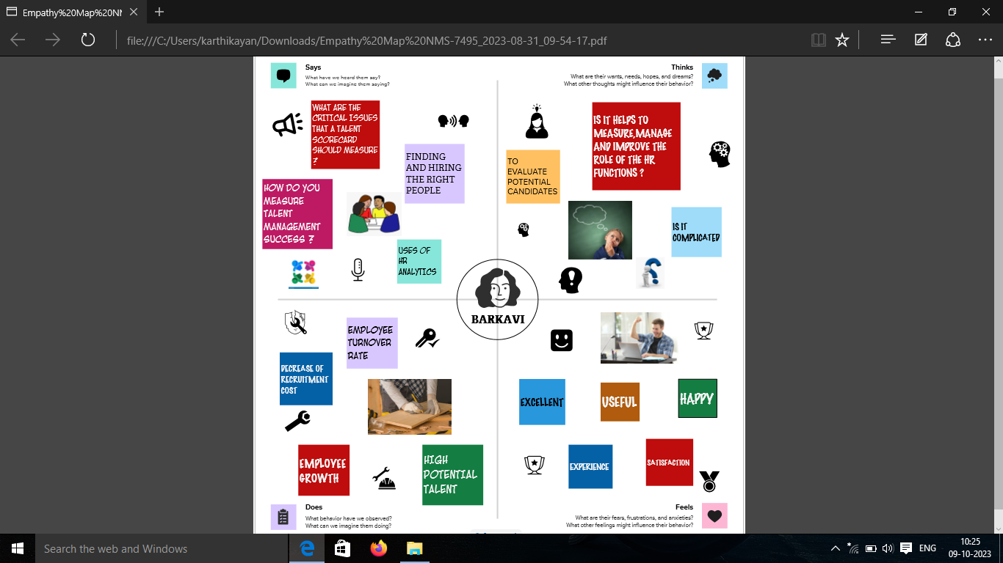

2.2 IDEATION & BRAINSTORMING MAP

Make a brainstorm map with mural website, in brainstorm we discussed the define problem and understanding the problem. First we have defined what are the problem and type in the question box.

Then it is a group idea and is written in the box person 1, person 2, person 3, person 4 now four person give different idea for problem.

Take best three idea and type in the last box.

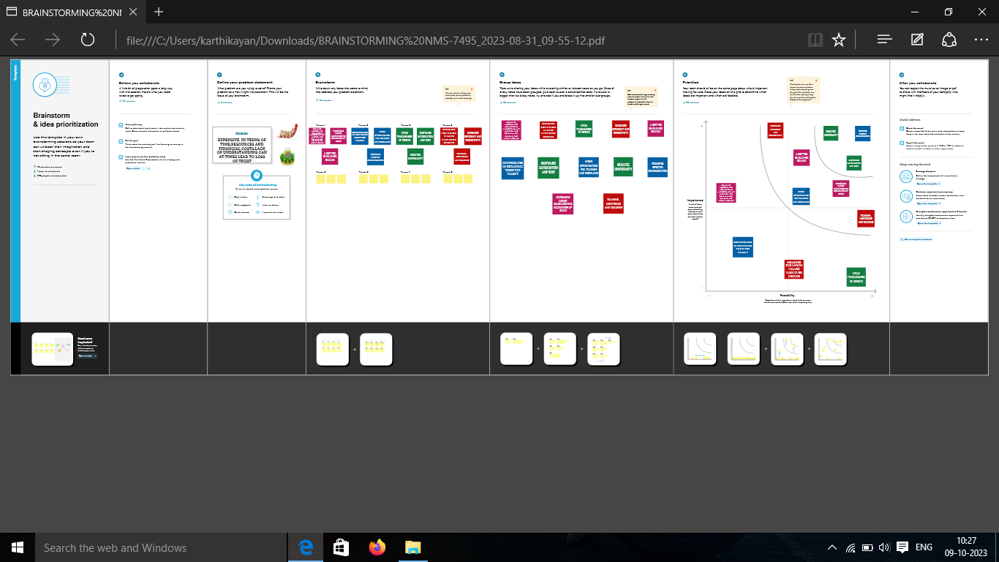

3. RESULT

Before opening the tableau desktop we had download the dataset for our project.

After download the dataset we open the tableau desktop.

After opening the option selected connect to data, select the MORE option and select the dataset.

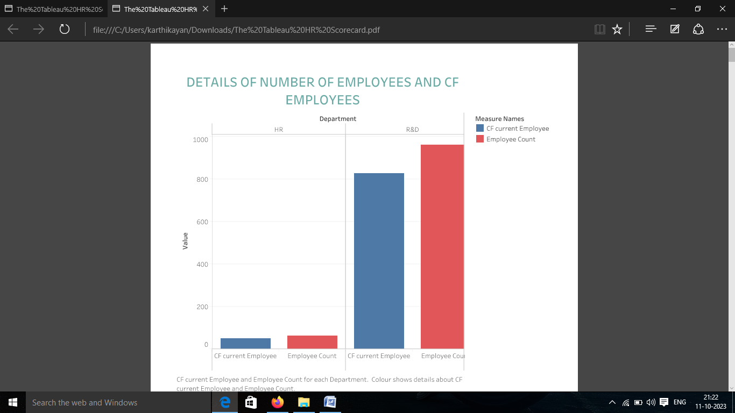

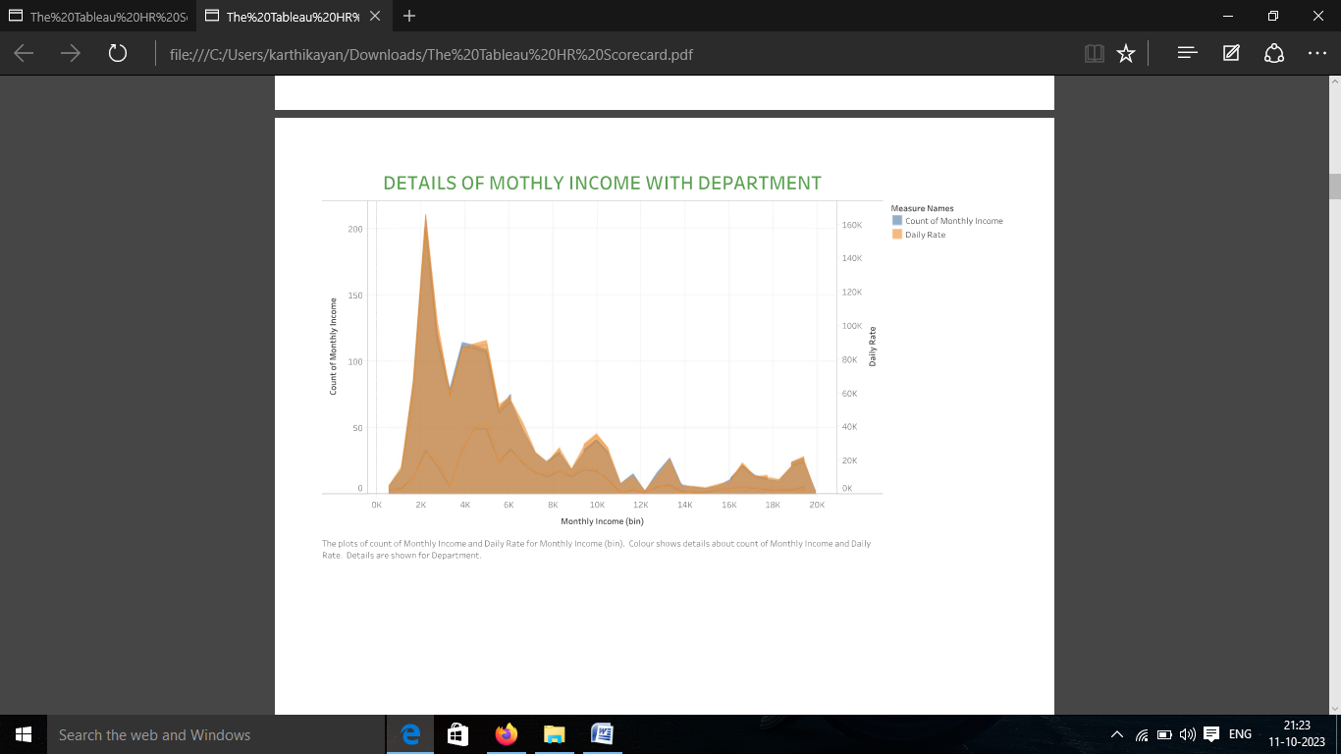

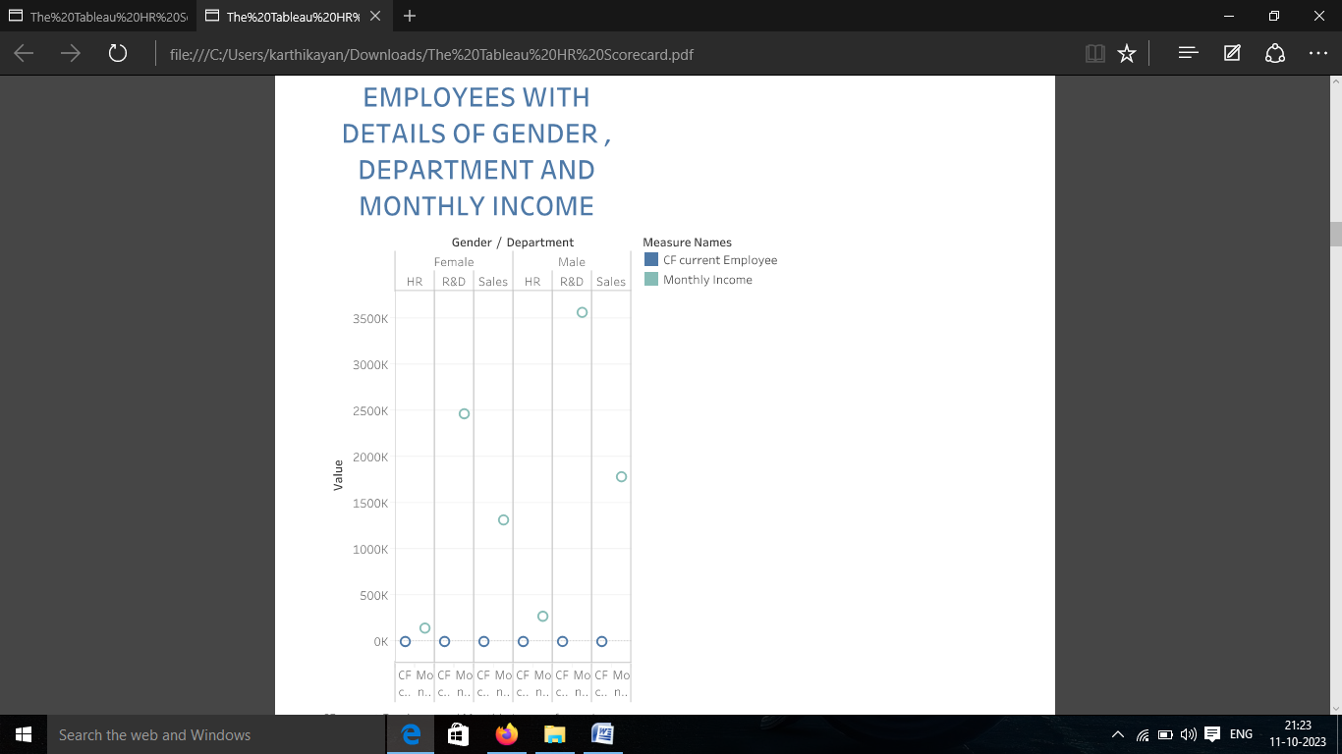

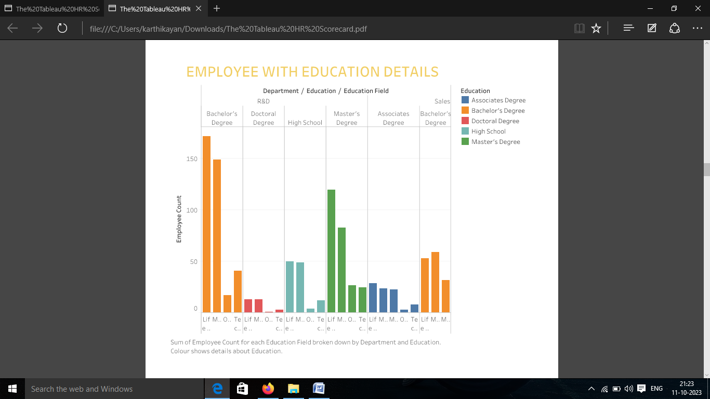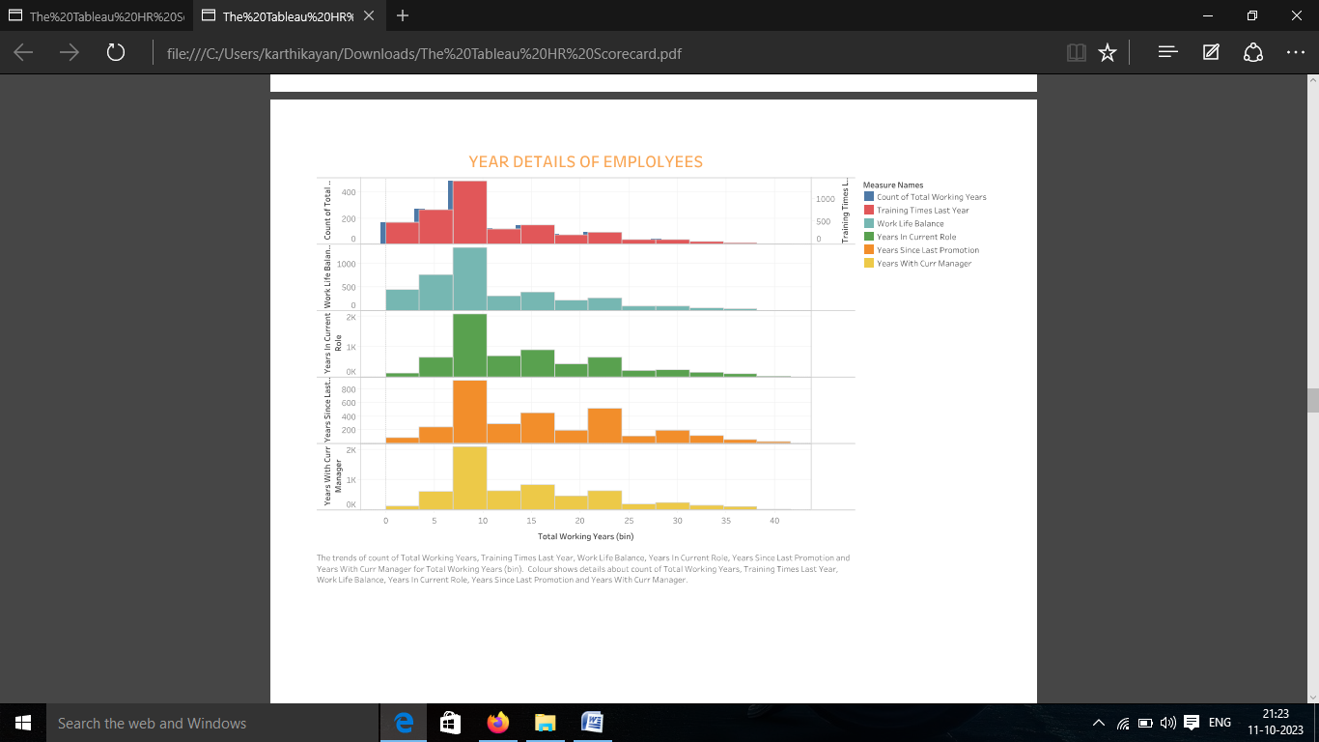

After finishing the analysis data, add a dashboard.

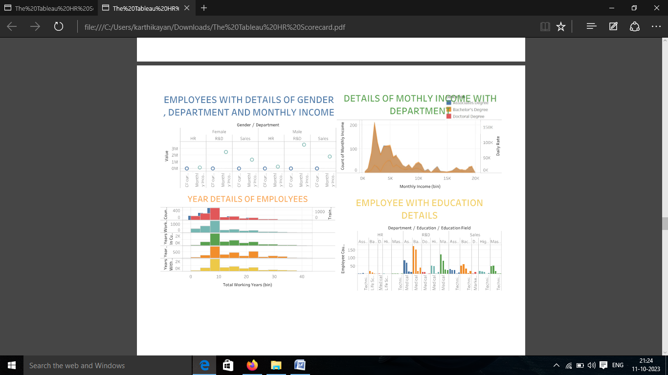

We created a story in the tableau desktop.

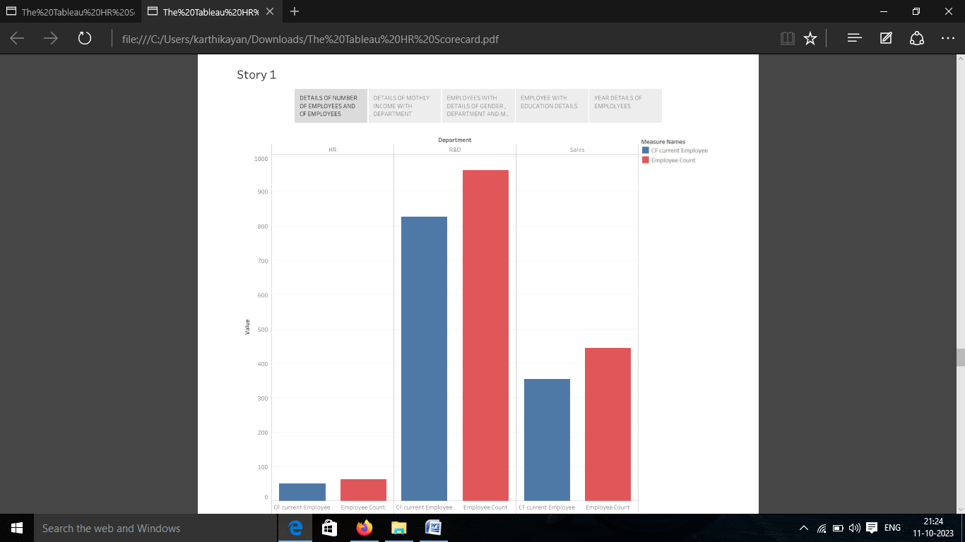

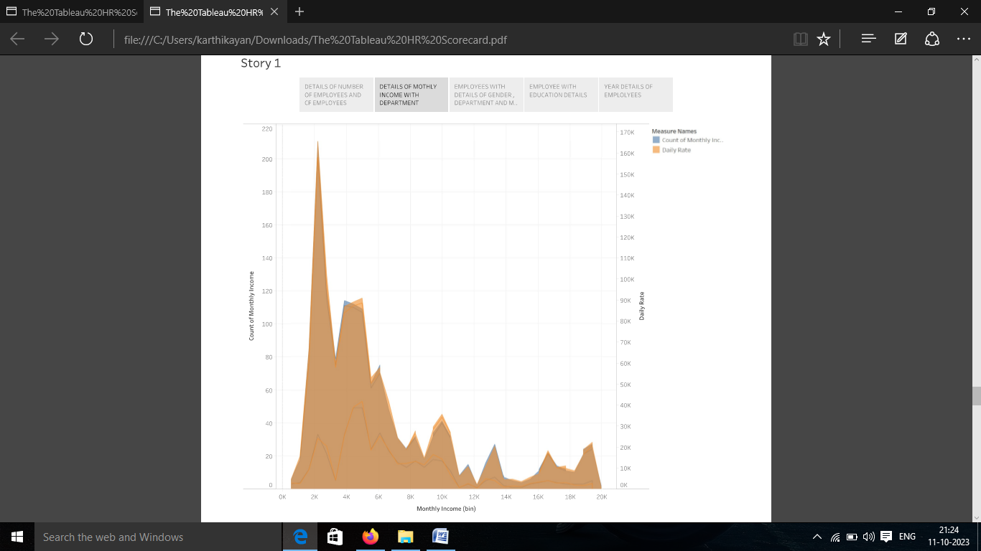

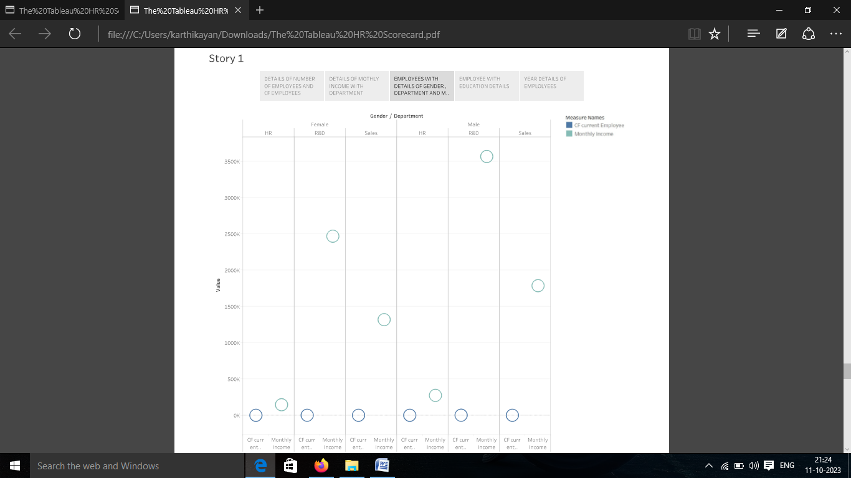

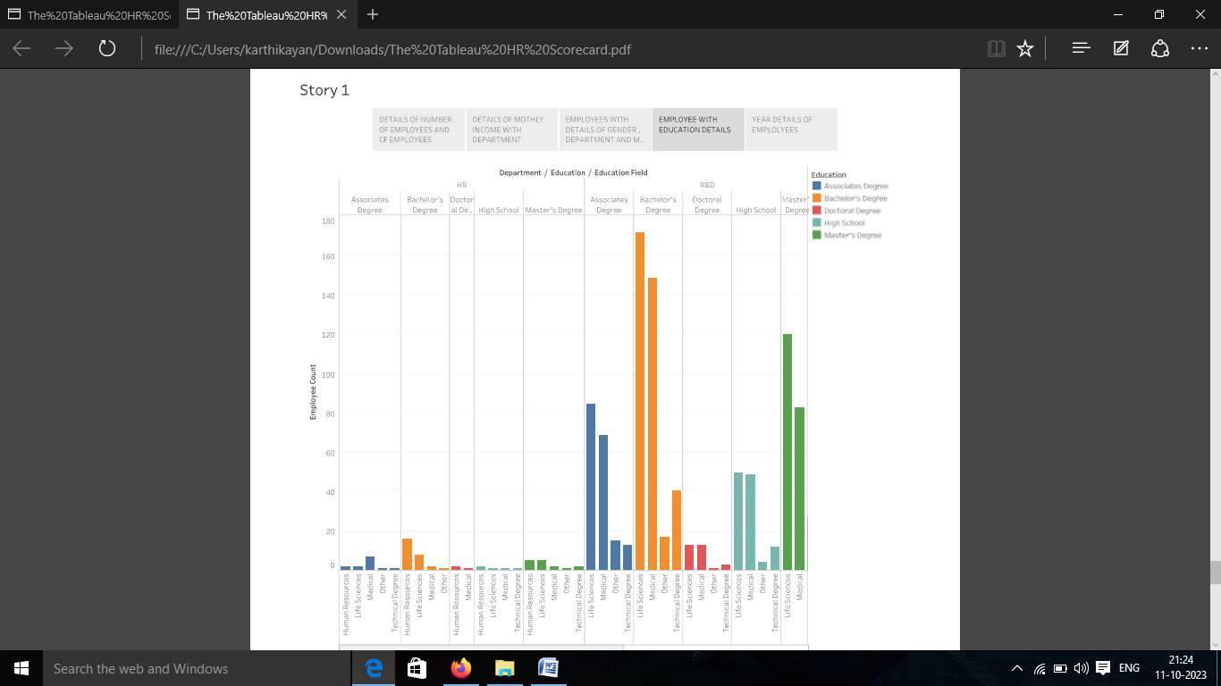

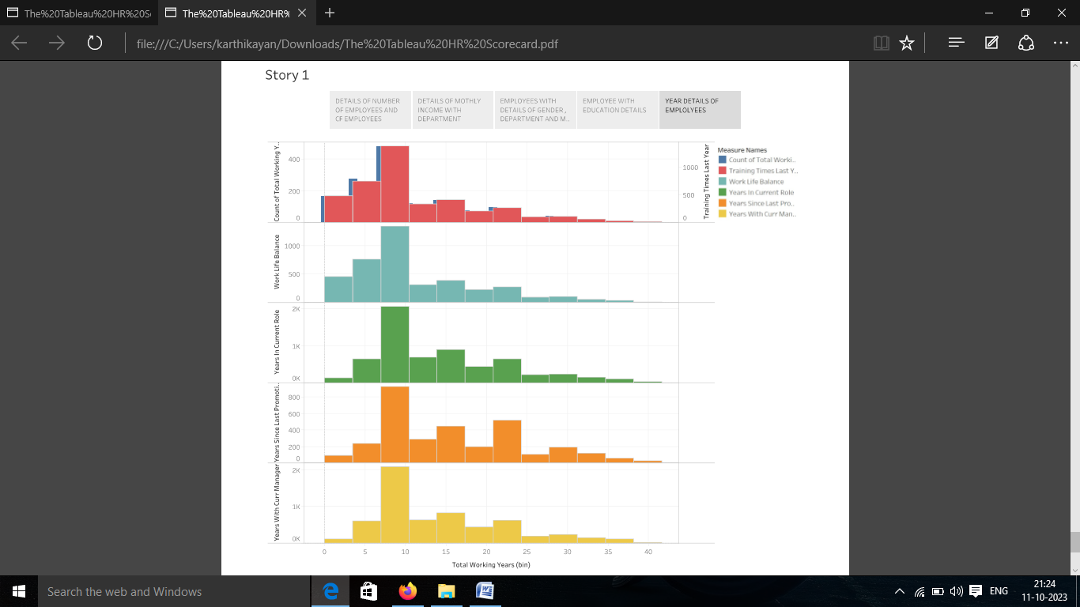

Sign into the tableau account.

Publish the workbook in the tableau cloud.

Upload the project in the Github.

4. ADVANTAGES

It is used to get Better employee retention, Easier employee attraction, Stronger compliance, Greater uniformity and Increased performance.

DISADVANTAGES

Lack of support from line managers can impede the level of commitment from employees. HR and management by not reaching to proper agreement.

5. APPLICATION

The HR scorecard is that becomes easier to align HR goals and strategies with the whole organization. It is a great way to share the information with our team, so they can stay up to data in their department or work area.

6. CONCLUSION

By collecting and analyzing data related to the people in an organization, HR analytics can help make data-driven decisions, measure the impact of HR initiatives and shape the future of work.

7. FUTURE SCOPE

It is easy to analyse the data to measure the success in talent management for the business and other purposes.